**Model-View-Controller (MVC) Programming**

MVC is a type of software architecture design pattern. Its main focus is to separate functionality, interface, and logic of a web application which encourages organized programming (Patel 2019). This is especially useful for collaboration work between multiple developers on a single project. MVC essentially consists of three components, which are model, view, and controller.

**Model**

The model in MVC is generally the component of the web application that stores data and its related functionalities (Guru99 2020). It can represent the data that is transferred between different controller components. An example of this would be in the BMI web application. The models of the web application were the ‘weight’ and ‘height’ data. These models were then used to calculate the BMI based on the given data and output a suitable feedback. Another example would be the BICT Unit Search Filter web application. The ‘unit code’, ‘unit description’, and ‘unit type’ models were used to filter the table consisting of units in order to search for a specific unit. The filter function takes in what kind of desired model data that was inputted by the user and modifies the table based on the input.

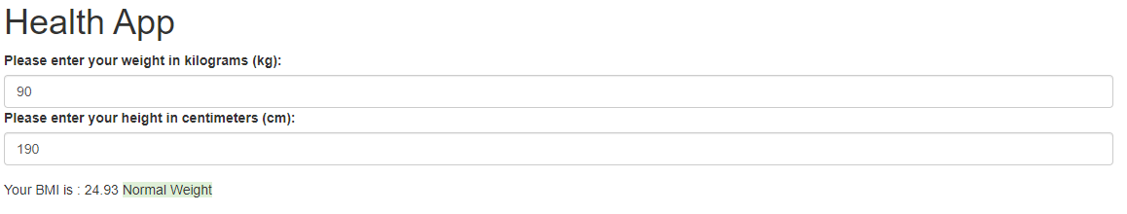

Figure 1: BMI calculated using 'weight' & 'height' models

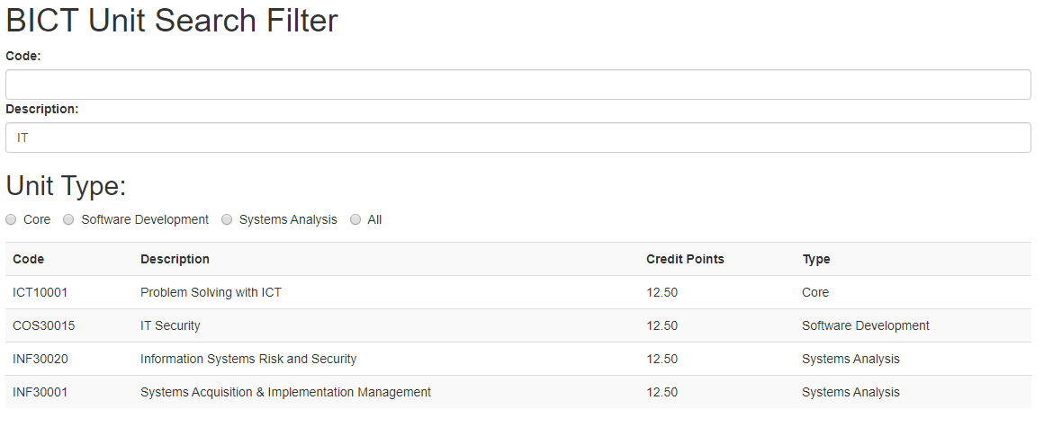

Figure 2: Table contents filtered using 'unit description' model data

**View**

The view in MVC represents the user-interface components of a web application (ongraph 2016). Basically, whatever that can be seen by the user on a web application and interact with it is the view component in MVC. In other words, they provide a means for the user to interact with the web application in order to produce a certain output. This includes HTML elements, CSS styling, and Bootstrap plug-ins. An example would be like the form elements in the Phone Cloud Registration web application that allow users to input data in. Bootstrap plug-ins provide a way to greatly enhance the view component of an MVC web application visually. Grid systems allow the web elements to be positioned appealingly all while being able to fit different screen sizes. Form control being applied on HTML form elements makes them more appealing. Web application contents like ‘h1’ and ‘p’ can also be positioned accordingly with Bootstrap. Directives in Angular can also be used to produce web elements. The table contents in the BICT Unit Search Filter web application were created using a loop directive rather than using HTML alone, which can be handy for web developers.

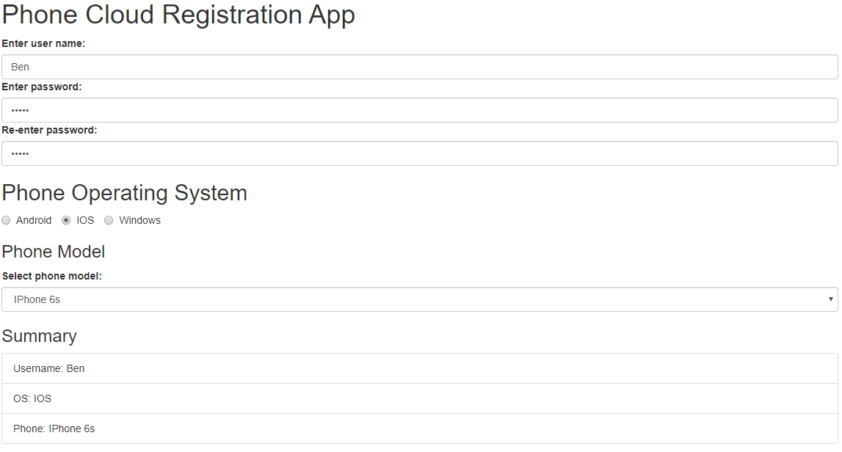

Figure 3: Example of grid system, form control, and other styles

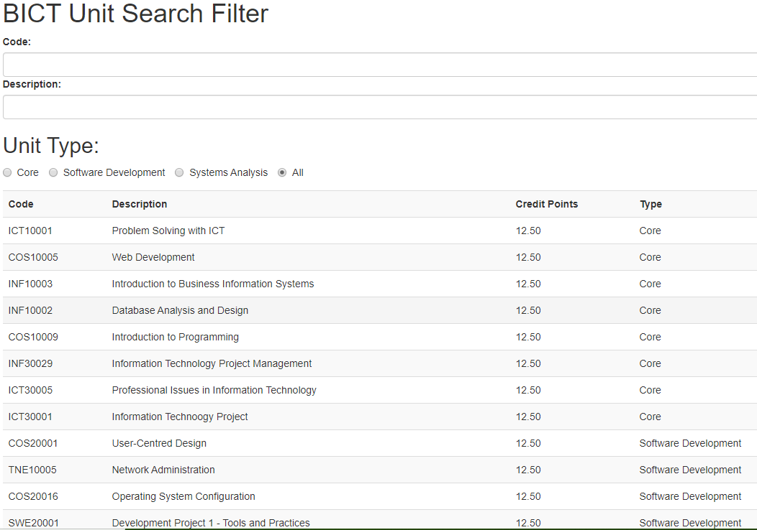

Figure 4: Table contents generated via loop directive

**Controller**

The controller in MVC deals in handling user inputs in a web application (Guru99 2020). The controller acquires inputs from the user and informs the model or view to update accordingly. In a sense, the controller acts as a ‘middleman’ between the model and view. An example would be the Number Guessing Game web application. As the user inputs a number to guess, the controller obtains the input and compares it to the random generated number model data. If it matches, it will inform the feedback to change its contents to let the user know that he/she has guessed correctly.

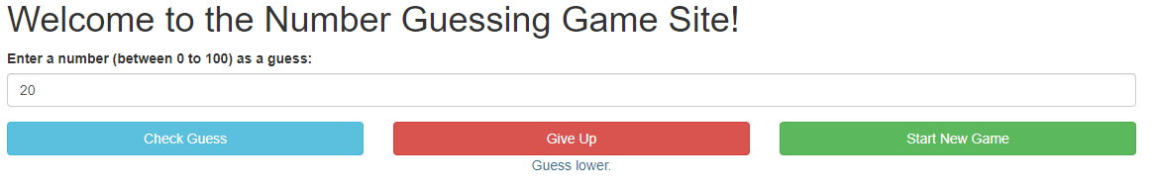

Figure 5: View informed to display 'Guess lower'

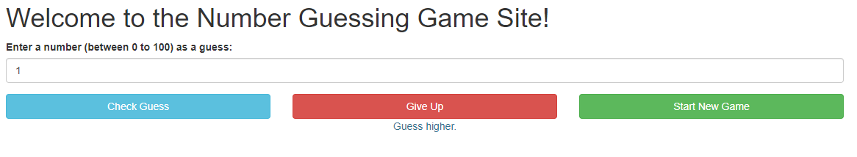

Figure 6: View informed to display 'Guess higher'

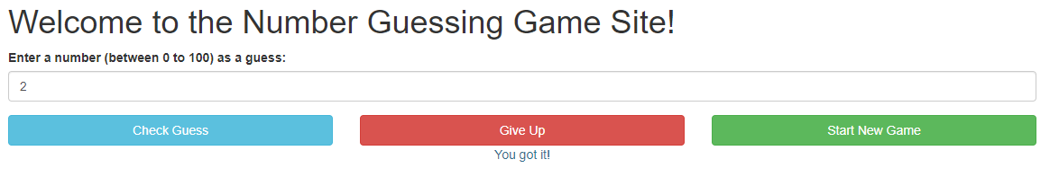

Figure 7: View informed to display 'You got it!'

**References:**

Guru 99 2020, *MVC Tutorial for Beginners: What is, Architecture & Example*, Guru 99, viewed 30 April 2020, <https://www.guru99.com/mvc-tutorial.html>.

ongraph 2016, ‘What is MVC Architecture in a Web Based Application?’, *OnGraph Technologies*, viewed 30 April 2020, <https://www.ongraph.com/what-is-mvc-architecture-in-a-web-based-application/>.

Patel, D 2019, ‘An Introduction to MVC Architecture: A Web Developer’s Point of View’, *DZone*, viewed 30 April 2020, <https://dzone.com/articles/introduction-to-mvc-architecture-web-developer-poi>.